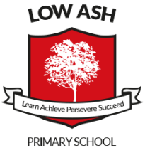
Recommended Reading List for Year 1

Here is a list of recommended books that you may enjoy reading with your child. We have tried to include a range of different texts, including; classics, poems, plot twists and teacher favourites.

- Traditional Stories (e.g. Sleeping Beauty, Rumpelstiltskin, Rapunzel, Puss-in-Boots, The Princess and the Pea, Pinocchio, The Pied Piper of Hamlin, Jack and the Beanstalk)
- Aesop’s Fables (e.g. The Hare and the Tortoise, The Boy Who Cries Wolf, The Monkey as King etc.)
- The Tale of Peter Rabbit (23 Book Series) by Beatrix Potter
- The Cat in the Hat, Green Eggs and Ham by Dr. Suess
- The Night Before Christmas by Clement Clarke Moore
- The More it Snows by A.A. Milne
- The Wolf Story: What Really Happened to Little Red Riding Hood by Toby Forward
- The Three Little Wolves and the Big Bad Pig by Eugene Trivizas
- Grandad’s Island by Benji Davies
- Wanted: The Perfect Pet by Fiona Robertson
- Owl Babies by Martin Waddell
- The Book with No Pictures by B.J. Novak
- Lost and Found by Oliver Jeffers
- Dogger by Shirley Hughes
- Zog by Julia Donaldson
- The Fish Who Could Wish by John Bush
- Wonkey Donkey by Craig Smith
