At Low Ash we know that learning to spell is an essential skill, and in order for children to become successful writers they need to spell accurately. Within school, children will learn the rules and conventions of the spellings, alongside systems and strategies needed to become confident spellers. In Reception, Year 1 and Year 2 the children have daily phonic lessons where they learn phonemes and graphemes and high frequency words. In Years 1, 2, 3, 4, 5 and 6 the children will also be taught spelling, which focuses on acquiring knowledge of spelling conventions patterns and rules. This gives children the opportunity to learn specific spellings, including statutory word lists, common exceptions and personal/topic spellings. Years 1 to 6 will have a weekly spelling test. All the words your child will be tested on will be sent home on a weekly basis. We encourage families to practise their child's weekly spellings wherever possible through the week. We believe learning to spell is most effective when it is done in an enjoyable and interesting way. Below are a range of spelling activities, games and strategies to support you and your children with their spelling at home. The spelling test will be recorded in a book which the children will bring home allowing you to see how your children did with their spellings. This book will also provide a place to practise their spelling strategies.

Activities and Games
The following games and activities are suggestions for effective and enjoyable ways for helping your child with their spellings.
Bubble Writing Write your spelling word in bubble letter. An easy way to do this is to write each letter of the word with a spaces between them, then draw around the letter to create a bubble version surrounding it.

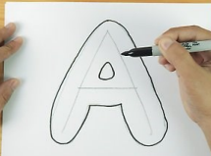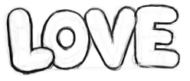

Spell With Objects
Spell out your words using objects in your house. This can be anything small like dice, sticks, straws or spoons.
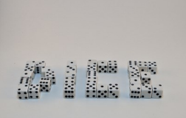

Missing Letters
Choose one of your spellings. Write it out with letters intentionally missing. Ask your child to find the missing letter. Write it in if they are correct and if not, draw the head of the snowman. The object of the game is for the child to guess the word before you have completed the drawing of the snowman.
Guess Who
Your child should write one of their spellings without you knowing what it is. You have to ask a question e.g. does it begin with ’th’? Can I sound it out? Your child answers the questions until you can guess the word.
Silly Sentences
Ask your child to write ten silly sentences using their spelling words. Encourage them to underline their spelling words. Example: My dog wears a blue and purple dress when he takes a bath.
Pyramid Writing
Write one letter of your spelling at a time on top of each other creating a pyramid shape. When you have finished draw the outline of the pyramid around it.

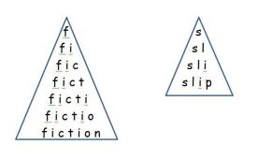
Spelling Scrabble
Write out your six spellings, try to join your spellings where the letters are the same.

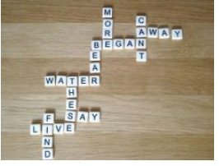

Spelling Scramble
Write all of the letters of your child's spelling in a random order and ask them to rearrange the letters to create the word. Rainbow Writing Write each letter of your spelling in a different colour.
Speed Writing
Choose a word from your spelling. Have a competition to see how many times you can write the word in a chosen time. This can be any time that works for you. You can try and beat your own score or compete with someone at home.
Look, say, cover, write, check
This is probably the most common strategy used to learn spellings. Look: first look at the whole word carefully and if there is one part of the word that is difficult, look at that part in more detail. Say: say the word as you look at it, using different ways of pronouncing it if that will make it more memorable. Cover: cover the word. Write: write the word from memory, saying the word as you do so. Check: Have you got it right? If yes, try writing it again and again! If not, start again – look, say, cover, write, check.
Drawing an Image
Around the Word This strategy is all about making a word memorable. It links to meaning in order to try to make the spelling noticeable.

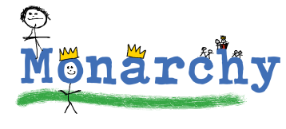
Words Without Vowels
This strategy is useful where the vowel choices are the challenge in the words. Write the words without the vowels and have your child place the vowels into the word. For example, for the word field: f ld
Clapping or Secret handshake (identify the syllables in a word)
Try clapping along with the syllables of your spelling word. Create a secret handshake with someone that helps you to remember the syllables by making each move on each syllable. Say it out loud as you do it.

