Pre-Stage 1: Reminder of Expectations
1 | Verbal Warning  We will not speak with home | Low-level disruption  Swinging on chair, calling out, answering back or disrupting the learning of others  Lack of respect for school property
2 | 5-minute reflection  *Y4-6 lose behaviour point | Continuing low-level disruption  You have not responded to your verbal warning
3 | 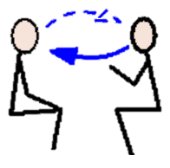  *10-minute reflection  We might need to speak with home | Inappropriate behaviour or language that was unintended  Swearing (with no understanding of meaning), any form of discrimination  Low-level physical contact  Pushing to get somewhere  Irritating physical contact e.g. tapping someone repeatedly  Deliberate damage to school property or resources
4 | *Move to another class  + 10-minute reflection  We will speak with home | If it’s your third 10-minute reflection in 1 week  Physical contact but you didn’t mean to hurt the other person  e.g. Pushing to the front and someone falls over  Damage to school property or resources that cannot be easily fixed  e.g. sawing the table with a ruler, graffiti  Refusal to follow an adult’s instructions
5 | *Visit to Phase Leader or FLT member  NOTE: minimum sanction is missing of next break/lunch  We will speak with home | Intentional inappropriate behaviour or use of language  Swearing or any form of discrimination  Physical violence that intentionally causes harm  Punching, kicking, fighting, push and/or pulling with deliberate force  Lasting damage to school building, property or resources  IT equipment, windows etc
6 | 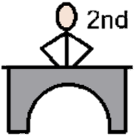  *Visit to Mr Hurst, Mrs Robinson  or Miss Grimshaw  We will speak with home | After two visits to the Phase Leader in 1 week
7 | *Visit to Headteacher  We will speak with home | Further red or amber incidents even after visiting Mr Hurst, Mrs Robinson or Miss Grimshaw

