Whole School Behaviour Guide

Rewards and Sanctions
 | Merits & Behaviour Points  Used during lessons only, for following the school’s Golden Rules | House Tokens  (from Autumn 2 2022)  Used to reward pupils for displaying a wider range of positive behaviours across school. | Restorative Practice & Sanctions
Reception to Y3 | Pupils accumulate merits and receive rewards at achievement assembly. (bronze, silver, gold etc ad in previous years) | Are issued via a house token to pupils for any positive behaviours displayed around school.  Additionally, for any other positive behaviour or achievement during lessons outside of the golden rules i.e. improved spelling score, homework challenge etc. | Continued use of restorative practice board to resolve conflict.  Use of behaviour ladder, in conjunction with restorative practice board, when choosing appropriate sanctions etc.  (See behaviour ladder)
Y4 to Y6 | Pupils can earn up to 5 behaviour points during a school day.  Pupils accumulate points and can spend them on a weekly basis at a points shop. | Same as above | Same as above

Merits (Reception - Y3)

- Pupils will receive merits, but only during lesson times;

- These are to be awarded for following one or more of the Golden Rules;
  - Be kind and caring towards others
  - Listen carefully and follow instructions
  - Be focussed and committed to learning

- Pupils accumulate merits and are awarded the following rewards during the weekly Achievement Assembly:

- Merits are not to be awarded for any other positive behaviours outside of classroom learning etc as this will be covered by the use of House Tokens.

25 merits | 50 merits | 75 merits | 100 merits | 125 merits | 150 merits | 175 merits
bronze badge | silver badge | gold badge | gold star badge | bronze medal | silver medal | gold medal

In year 3 pupils will get the opportunity to choose Low Ash stationary instead of their badge should they wish to do so.

Behaviour Points (Y4 - Y6)

- These will replace the use of merits for rewarding positive behaviour during lesson times.

- The school day is now split into 5 sessions as shown in the example timetable below:
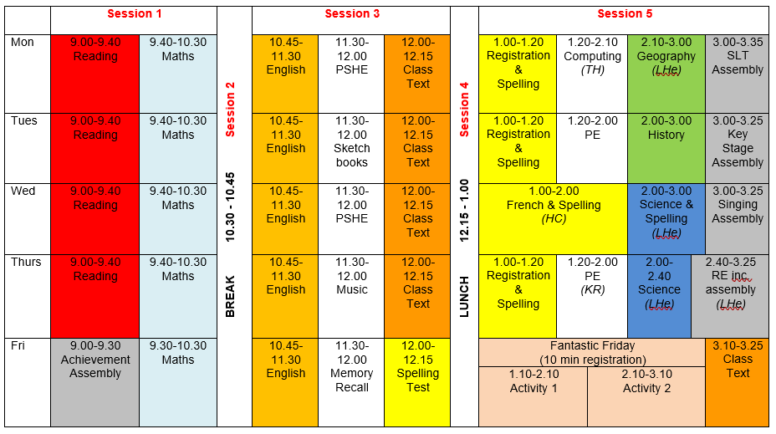
- Pupils who follow all of the Golden Rules for the session will receive their point.
- Pupils will keep their point unless they receive 2 warnings as per the Low Ash Behaviour Ladder;
- Pupils will start each new session with a behaviour point
Behaviour Point Rewards (Y4 – Y6)
- Each week, pupils will have the opportunity to visit a ‘Points Shop’. Here they can redeem their points for a range of prizes. Pupils may decide to redeem their points weekly for a smaller item or may save them up for a half term/term or even a year for a bigger reward eg. a funded school trip.

